**Maui wildfires leave trail of death and destructioSn**

By [Aditi Sangal](https://www.cnn.com/profiles/aditi-sandal), Mike Hayes, [Elise Hammond](https://www.cnn.com/profiles/elise-hammond) and [Maureen Chowdhury](https://www.cnn.com/profiles/maureen-chowdhury), CNN

Updated 12:29 AM EDT, Tue August 15, 2023

Video Ad Feedback

See what it's like in fire-ravaged Lahaina as aid efforts begin

02:58 - Source: [CNN](https://www.cnn.com/)

**What we're covering**

* The official death toll [has reached 99](https://www.cnn.com/us/live-news/hawaii-maui-wildfires-08-14-23/h_564fb15196b845bd9896a4eb7780293b) in the wildfires on Maui and is expected to increase “significantly” in the coming days, Hawaii Gov. Josh Green said on CNN.The blaze that devastated the historic town of Lahaina is now the [deadliest US wildfire in over 100 years](https://www.cnn.com/2023/08/14/us/maui-wildfires-what-we-know/index.html), officials said.
* Officials will begin [releasing the names](https://www.cnn.com/us/live-news/hawaii-maui-wildfires-08-14-23/h_d6b5a59f175bfe503bceae526c15d2bc) of the deceased Tuesday, Maui County Police Chief John Pelletier said during a Monday news conference.
* As residents sift through the ashes of what used to be homes and landmarks, some say the [island is struggling to provide housing](https://www.cnn.com/2023/08/13/us/maui-wildfires-hurricane-dora-sunday/index.html) for those displaced by the fires.
* Here’s [how to help](https://www.cnn.com/2023/08/10/business/charity-real-donation-money-going) victims of the wildfires in Hawaii.
* *In an area with limited connectivity? Get the latest news*[*here*](https://lite.cnn.com/)*.*

AllCatch UpLahainaVictims

**28 Posts**SORT BY           Latest           Oldest

10:47 a.m. GMT+8, August 15, 2023

**Nearly 2,000 housing units will be available for families displaced by fires**

From CNN’s Raja Razek

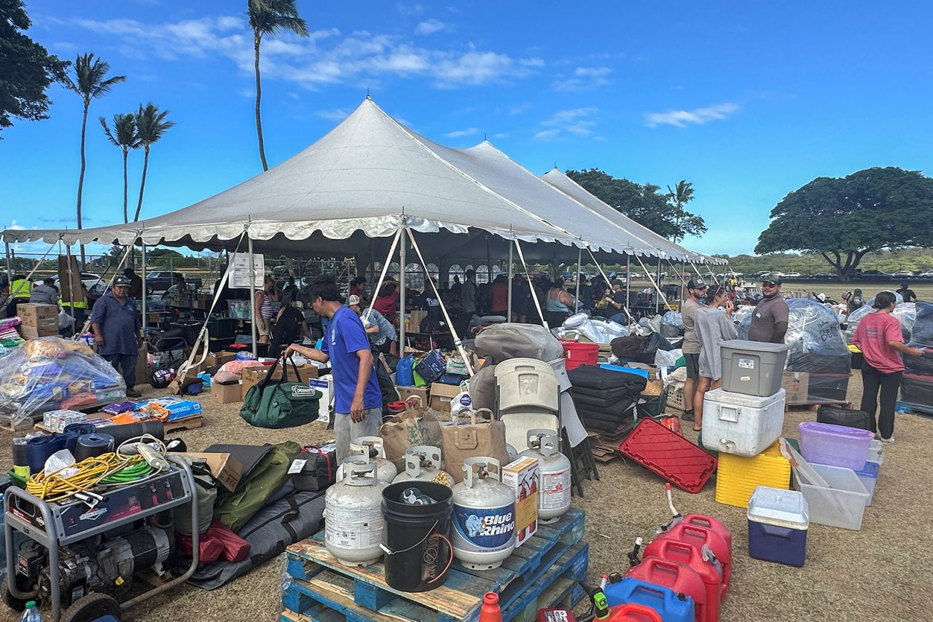

A view of a War Memorial Gym turned into donation and medical shelter to aid victims of the Maui wildfires in Kahului, Hawaii, on August 11.

Jorge Garcia/Reuters

Nearly 2,000 housing units have been secured as Maui officials scramble to house [thousands of residents](https://www.cnn.com/2023/08/13/us/maui-wildfires-hurricane-dora-sunday/index.html) whose homes were decimated by wildfires, officials announced Monday.

Officials have secured 402 hotel rooms and an additional 1,400 Airbnb units will be available on Tuesday, Hawaii Gov. Josh Green said in a news conference on Monday. Another 160 residents have also stepped up to volunteer to shelter displaced people in their homes.

About 222 displaced families have already been placed in housing, Green said.

“We anticipate at least 36 weeks of direct housing for individuals,” Green said. “You will probably go on much longer than that, just so people know. But we don’t want people to think that they are going to get housed and suddenly be asked to leave. They will be in 30-day increments which will be constantly reupped so people will get housed.”

A total of 1,418 people were staying at [emergency evacuation shelters](https://www.cnn.com/us/live-news/hawaii-maui-wildfires-08-14-23/h_38a798d3ad46930eb40b3016b44a96a8) as of Friday night, officials said previously.

More than 2,200 structures have been destroyed on the fires, 86% of them residential, Green said.

About 222 displaced families have already been placed in housing, Green said. People will likely require at least 36 weeks of housing assistance.

“The scale of the destruction is incredible,” Green said. “Our hearts are broken even a little bit more than when we were together 48 hours ago with the extra fatalities.”

County authorities signed a contract with the Red Cross on Monday and will be partnering with Federal Emergency Management Agency to make sure “everyone gets housed,” Green said.

An emergency proclamation that will assist residents with getting medications and medical care has also been signed, the governor said.

“We will be bringing hundreds and hundreds of mental health care workers into the state,” he added.

10:25 a.m. GMT+8, August 15, 2023

**Maui authorities will begin releasing identities of wildfire victims on Tuesday**

From CNN's Elizabeth Wolfe

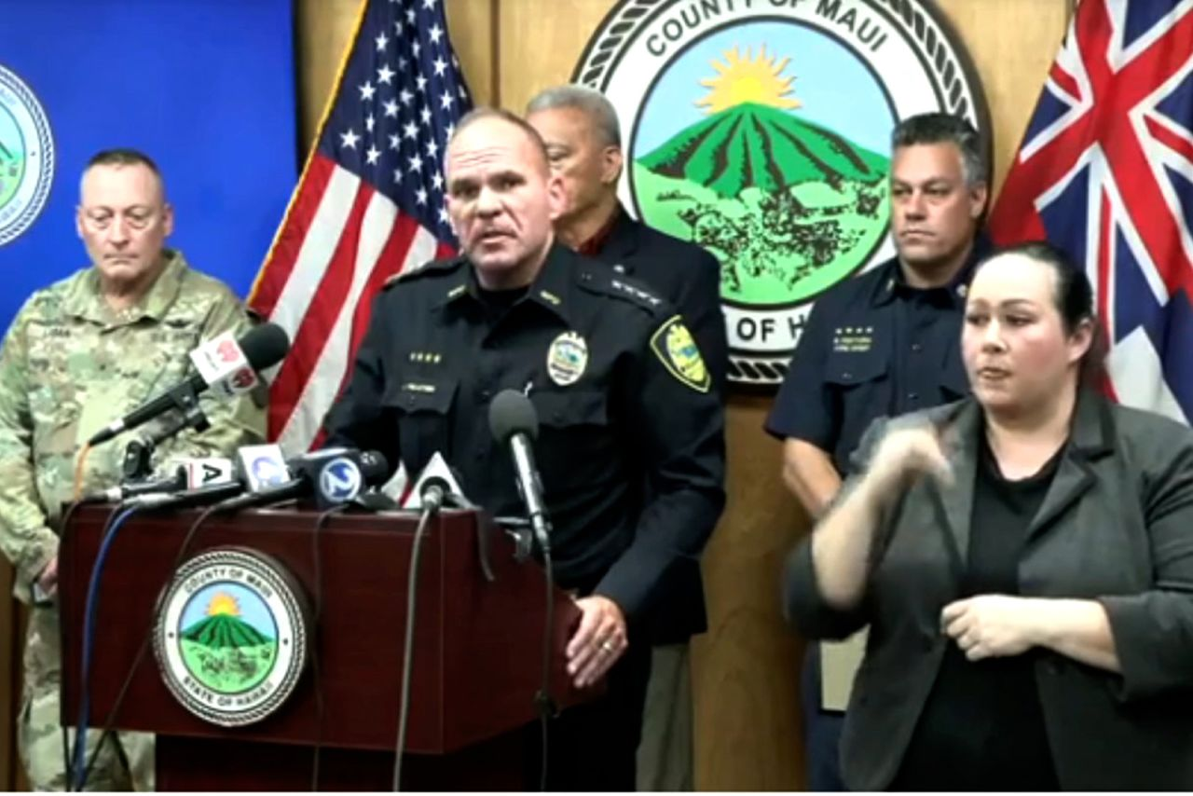

Maui County Police Chief John Pelletier speaks during a news conference on August 14, 2023.

Governor Josh Green/Facebook

Maui County authorities will begin releasing the identities of those killed in the wildfires that swept across the island, police announced during a news conference Monday.

[At least 99 people](https://www.cnn.com/us/live-news/hawaii-maui-wildfires-08-14-23/h_564fb15196b845bd9896a4eb7780293b) have been confirmed dead so far.

Police and county officials will release the names of people whose families have been notified, Maui County Police Chief John Pelletier said during a Monday news conference.

State law requires authorities to notify a victim’s family before releasing their name, he explained.

Meantime, crews continue to search areas impacted by the fires, he said.

“To date, 25% of the area has been searched,” Pelletier said. “We can only move as fast as we can, but we’ve got the right amount of workers, the right amount of teams doing it.”

8:49 a.m. GMT+8, August 15, 2023

**Actor Jason Momoa releases statement on Maui wildfires**

From CNN's Steve Forrest

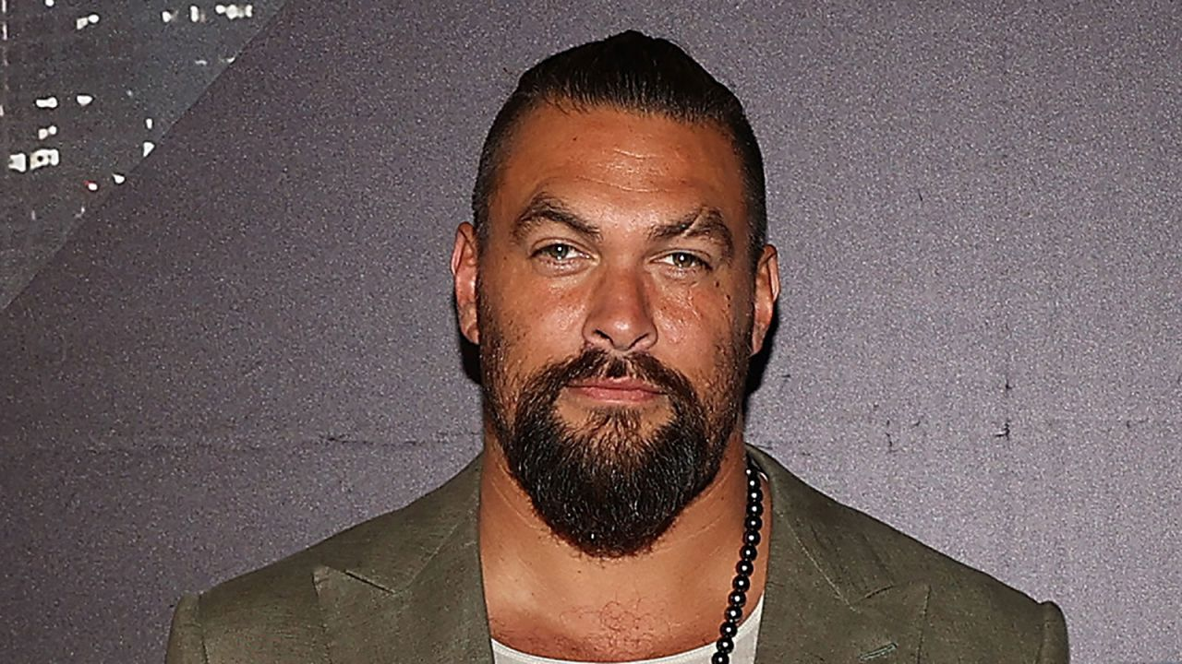

Jason Momoa seen on May 13.

Fiona Goodall/Getty Images/FILE

Actor Jason Momoa issued a statement Monday about the wildfires that ravaged Maui, saying “the destruction caused by these fires is heartbreaking, but our community’s resilience and strength will shine through.”

Momoa, who was born in in Honolulu, [had been actively posting on his social media](https://www.cnn.com/2023/08/11/entertainment/jason-momoa-maui-fires/index.html) in the aftermath of the fire that has left at least 99 people dead.

**Read Momoa’s latest statement below:**

My heart goes out to all those affected by the devastating fires across the Island of Maui. In times like these, we come together as an ‘Ohana, a family, to kāko’o and kōkua one another. The destruction caused by these fires is heartbreaking, but our community’s resilience and strength will shine through.  
I urge everyone to stay safe and heed the advice of local authorities. Let us all do our part to prevent the further spread of the fires and support those on the front lines, working tirelessly to protect our homes and natural treasures.  
Hawaii is home to unique and precious natural environments found nowhere else on earth and is a place of deep cultural significance to it’s people. It’s up to us to ensure that it remains a vibrant and thriving environment for generations to come. Let’s stand united, support each other, and work hand in hand to rebuild and restore what has been lost.  
Mahalo nui loa for your unwavering love for our islands.  
 All my aloha, J

8:48 a.m. GMT+8, August 15, 2023

**US Coast Guard deploys pollution response teams to minimize maritime environmental impact from Maui fires**

From CNN's Anna-Maja Rappard

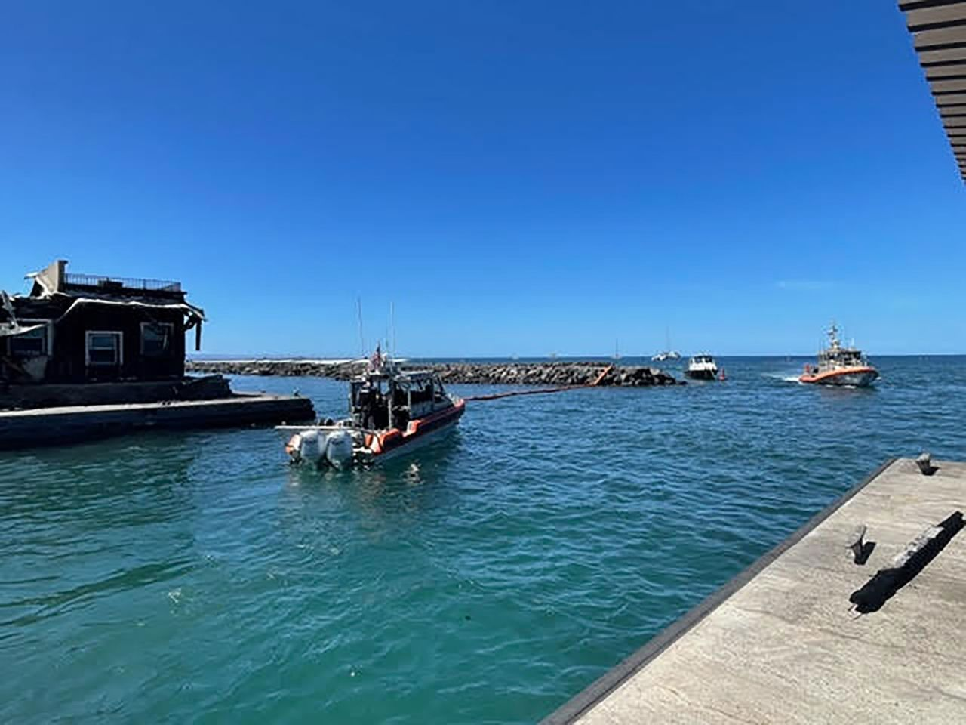

The US Coast Guard said its first responders will shift resources to the maritime environmental fallout from the wildfires.

US Coast Guard

The US Coast Guard in Maui has shifted its focus from search and rescue to containing potentially hazardous materials left behind by the fires.

“While the Coast Guard is always postured for search and rescue operations, we are also focused on minimizing maritime environmental impacts as a result of the Maui fires,” US Coast Guard Cmdr. Kyra Dykeman said in a [news release](https://www.news.uscg.mil/Press-Releases/Article/3492718/coast-guard-shifts-response-focus-to-maritime-environment-after-maui-fires/) Monday.

The agency said its first responders will shift resources to the fires’ maritime environmental fallout but will remain ready to respond to any new reports of individuals in the water.

The Coast Guard’s National Strike Force arrived on Maui last Friday to aid in the environmental response. The team includes highly-trained personnel and specialized equipment “to facilitate hazardous substance pollution incidents in order to protect health and the environment,” the release said.

The equipment being used in the new response includes sonar technology and a 100-foot boom placed at the mouth of the Lahaina Harbor, the agency said.

The shift in resources comes after the Coast Guard rescued [at least 17 people](https://www.cnn.com/us/live-news/hawaii-maui-wildfires-08-11-23/h_4c7fe1f7f0af9954d8e25d0761988995) last week who had fled into the ocean to escape the inferno that destroyed [Maui’s Lahaina community](https://www.cnn.com/2023/08/13/us/maui-wildfires-hurricane-dora-sunday/index.html).

8:18 a.m. GMT+8, August 15, 2023

**Hawaii officials believe emergency sirens were immobilized by extreme heat from fire, governor says**

From CNN’s Raja Razek

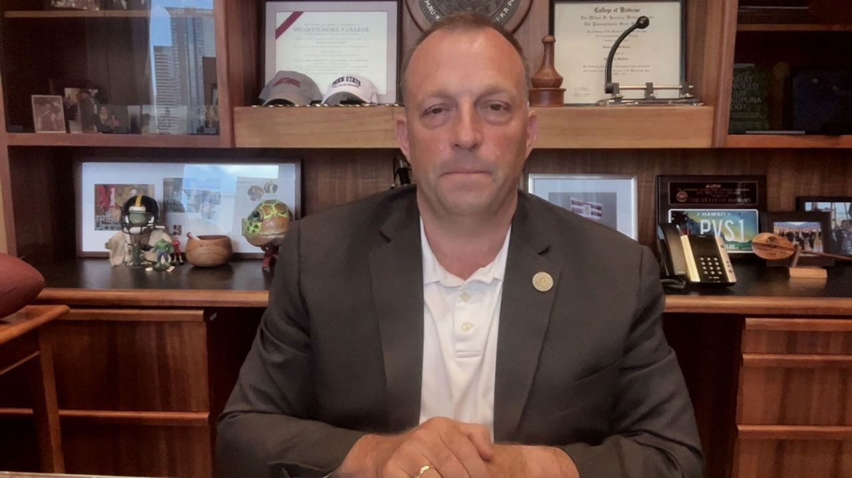

Hawaii Gov. Josh Green appears on CNN on Monday, August 14.

CNN

Officials believe that emergency sirens on Maui were “essentially immobilized” by the extreme heat of the wildfires that ripped through the island, Hawaii Gov. Josh Green said Monday.

“Now, typically we use sirens here for hurricanes and or tsunamis, but we are assessing that,” Green told CNN’s Wolf Blitzer.

The governor said it is going to take time to figure out what happened and that he asked those investigating to work with the Federal Emergency Management Agency and NASA in their assessment.

“So, we will get a lot of data. Data not just for the people of Hawaii but for the world,” he said.

Blitzer asked about power lines that were reportedly not shut off when the fire broke out, warning sirens that were not sounded and fire hydrants that ran dry.

“Your attorney general is currently reviewing the emergency response to this fire. When do you think the people will have more answers on these questions on what went wrong?” Blitzer asked.  
The governor replied: “I authorized that comprehensive review with our attorney general immediately — I think on the third day. That is very unusual. Actually, a lot of times people wait months or even years before they look into some of these matters.”

7:42 a.m. GMT+8, August 15, 2023

**How a devastating combination of conditions triggered America's deadliest wildfire in more than a century**

From CNN's Casey Tolan, Isabelle Chapman and Curt Devine

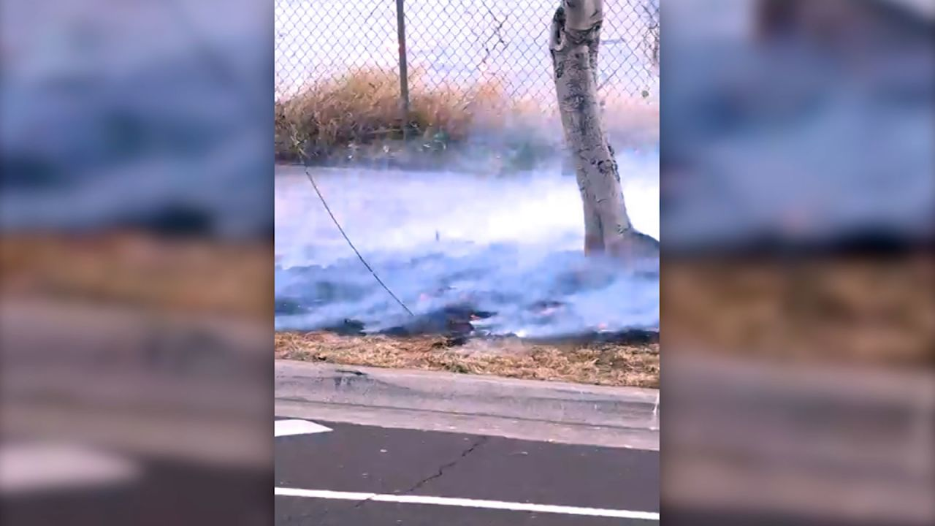

Shane Treu showed the downed powerlne during a Facebook Live video.

Shane Treu/Facebook Live

As gale-force winds rushed down the slopes of Maui’s Mauna Kahālāwai mountains early Tuesday morning, Shane Treu stood outside his home with a garden hose — one of the first people in Lahaina to fight what would become[America’s deadliest wildfire in more than a century](https://www.cnn.com/2023/08/14/us/maui-wildfires-what-we-know/index.html).

A power line on his street had been knocked down amid howling winds, Treu said in a Facebook Live video, which showed flames in the grassland across the street and thick smoke obscuring his sweeping ocean view.

While the cause of the fire has not been determined, observers have pointed to downed power lines, sputtering fire hydrants, and emergency alarms that sat silent as factors that hampered the response to the deadly blaze.

Now, amid the charred remnants of the disaster, residents and government officials are asking how the fire could have killed at least 99 people and sent others fleeing into the ocean — despite years of warnings that wildfires posed a serious threat to the island.

**Lawsuit alleges power lines a factor:**As the fires grew last Tuesday, they were buffeted by extreme winds caused by Hurricane Dora, which was passing hundreds of miles south of Maui. Those winds also battered power lines on the island, and dramatic videos show lines swaying and being toppled in the gusts.

Bulletins from the county reported downed power lines blocking roads around Lahaina, and some residents fleeing the area said that their escape routes were blocked.

Now, some locals are casting blame on Hawaiian Electric, the state’s biggest utility, for not shutting off power to high-risk areas — and claiming that its power lines could have sparked the deadly fire.

Jim Kelly, a spokesperson for Hawaiian Electric Company, said the company does not have a “formal power shutoff program” and that electricity powers the pumps that provide water for firefighting.

**Alarms and fire hydrants:**As flames spread through Lahaina, critical systems for evacuating residents and fighting fires — the emergency alerts network and fire hydrants —appeared to break down, failures that are now getting more attention as residents try to figure out what went wrong.

Officials have said that the speed of the fire through town made it “nearly impossible” to issue advance evacuation orders, as Bradford Ventura, the county fire chief, put it in a Thursday news conference.

Even the state’s vaunted integrated outdoor siren warning system — the largest in the world, with about 400 alarms — was not activated during the fires, according to Hawaii Emergency Management Agency spokesperson Adam Weintraub.

**Land conditions and climate change:** Even before the winds from Hurricane Dora fed the flames on Maui, a dangerous combination of drought and dry grasses set the stage for the disaster by transforming the island into a tinderbox.

Like large swaths of the mainland United States, Hawaii is in the midst of a drought, with parts of Maui suffering from severe drought conditions. This has become more extreme and common across the archipelago and others like it in the Pacific, according to the US National Climate Assessment released in 2018.

People have also introduced nonnative fire-prone grasses and shrubs that now cover nearly a quarter of Hawaii’s total land area.

[**Dig deeper.**](https://www.cnn.com/2023/08/14/us/hawaii-maui-wildfire-power-lines-invs/index.html)

7:02 a.m. GMT+8, August 15, 2023

**Death toll in Maui wildfires rises to 99, Hawaii governor says**

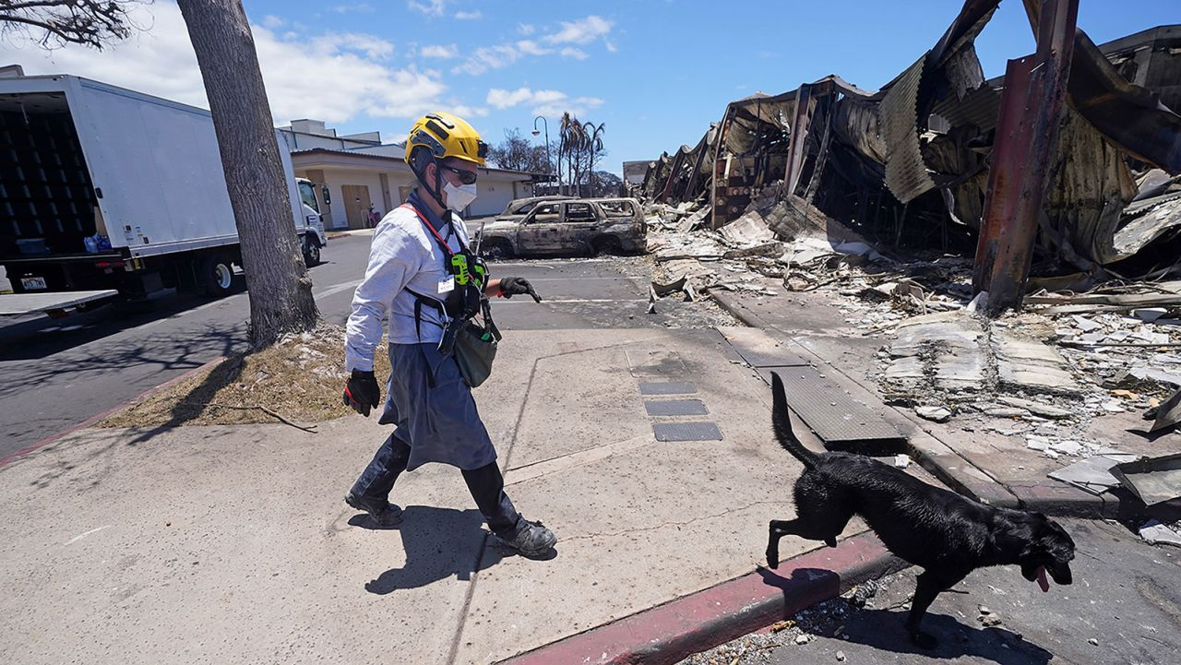

A member of the search and rescue team walks with her cadaver dog near Front Street on Saturday, Aug. 12, in Lahaina, Hawaii.

Rick Bowmer/AP

The death toll from the Maui fires has now risen to 99, Hawaii Gov. Josh Green told CNN.

“It will go up very significantly. We’re exploring all the numbers,” the governor said. He said in the next 10 days, the number of deaths could as much as double.

He said search efforts are continuing and [cadaver dogs](https://www.cnn.com/2023/08/14/us/cadaver-dogs-maui-wildfires-victims/index.html) are looking for remains, but conditions are making progress slow. The dogs at some points could only work for about 15 minutes at a time because the area is still so hot, Green said.

About 85% of the fire in Lahaina is contained, but some embers are still burning.

“It is a tragedy beyond tragedies. We, of course never expected to see this anywhere in America, but we are, you know, we’re burdened by the circumstance of climate change and tragedy at the same time. That is why this fire occurred for the most part,” Green said.

The governor has [authorized a comprehensive review](https://ag.hawaii.gov/wp-content/uploads/2023/08/News-Release-2023-36.pdf) “so we have every answer going forward.”

Green and other officials are expected to give an update at 9:30 p.m. ET.

*CNN’s Raja Razek contributed reporting to this post.*

4:53 a.m. GMT+8, August 15, 2023

**Wildfire damage could cause a local recession as Hawaii activates more National Guard. Here's the latest**

From CNN staff

More members of the [Hawaii National Guard have been activated to respond to the wildfires](https://www.cnn.com/us/live-news/hawaii-maui-wildfires-08-14-23/h_ba756cd8ce3f0d28858361dbdadd1ea2) on Maui, the Pentagon said, and Indo-Pacific Command remains poised to respond should a request for more aid come in.

The Hawaii National Guard has now activated a total of approximately 250 guard members, Brig. Gen. Patrick Ryder said in a briefing Monday.

The National Guard are working with the Hawaii Emergency Management Agency and helping local law enforcement.

Meanwhile, Moody’s Analytics reported Monday that the wildfire damage is expected to have an [“astronomical” economic impact](https://www.cnn.com/us/live-news/hawaii-maui-wildfires-08-14-23/h_dc52a11c0c760cebcfbfb3a8a8cb7729) on the island and cause a severe local recession.

The economic toll could run between $3 billion and $7.5 billion, according to initial estimates released Monday.

While those estimates are smaller than the effects of [past major hurricanes](https://www.cnn.com/2022/10/03/economy/hurricane-ian-us-economic-impact-gdp/index.html), they’re higher than typical for wildfires, given the scale of the disaster and that it hit a fairly populated area with more “ferocity” than many [events in California](https://www.cnn.com/2020/10/17/us/california-wildfires-saturday/index.html) and other states, economists wrote.

*Here are the latest developments:*

* **Firefighters describe weak water pressure and failing hydrants during defense of Lahaina**: Several firefighters trying to contain the flames quickly approaching the historic town of Lahaina last week have described [weak water pressure and fire hydrants running dry](https://www.cnn.com/us/live-news/hawaii-maui-wildfires-08-14-23/h_ed27906365a880c351b3cb527869e48a), complicating an already perilous operation. “There was just no water in the hydrants,” Keahi Ho, one of the firefighters working in Lahaina told the [New York Times](https://www.nytimes.com/2023/08/13/us/lahaina-water-failure.html?smid=nytcore-ios-share&referringSource=articleShare).
* **Hawaii energy company’s stock slips after lawsuit blames wildfires on its power lines**: Hawaiian Electric’s stock [tumbled to a 13-year low](https://www.cnn.com/us/live-news/hawaii-maui-wildfires-08-14-23/h_735d1049ac23739572e1e07307976025) Monday morning, plummeting nearly 40% after a class-action lawsuit filed over the weekend alleged that Maui’s devastating wildfires were caused by the utility’s energized power lines that were knocked down by strong winds.
* **Biden administration commits to helping Maui recovery efforts**: President Joe Biden and his administration are [committed to supporting Hawaii “every step of the way”](https://www.cnn.com/us/live-news/hawaii-maui-wildfires-08-14-23/h_a7ebd4e836e01b1737918ab372f8c487) following the deadly Maui wildfires, Federal Emergency Management Agency (FEMA) administrator Deanne Criswell said Monday during a White House press briefing. [Biden is not expected to visit Maui](https://www.cnn.com/us/live-news/hawaii-maui-wildfires-08-14-23/h_a6333392d36bb7af26b2dfc07535031a) at the moment, White House press secretary Karine Jean-Pierre noted, but they will work with officials for potential opportunities.
* **Hawaii’s deadly wildfires will be “heavily studied”**:The wildfires that tore through the island of Maui and killed 96 people so far, will be [“heavily studied” by climate experts](https://www.cnn.com/us/live-news/hawaii-maui-wildfires-08-14-23/h_c8c3c62bb17aaf2c4bb02ecddc783b75) as well as US federal research agencies, scientists said.“There will be lots of research that will come out of NOAA in understanding specifically what caused this and the events that we’ve seen,” Sarah Kapnick, chief scientist with the National Oceanic and Atmospheric Administration, said in a call with reporters Monday.

4:19 a.m. GMT+8, August 15, 2023

**Maui wildfires' "astronomical" economic cost could be between $3 billion and $7.5 billion, Moody's estimates**

From CNN's Alicia Wallace

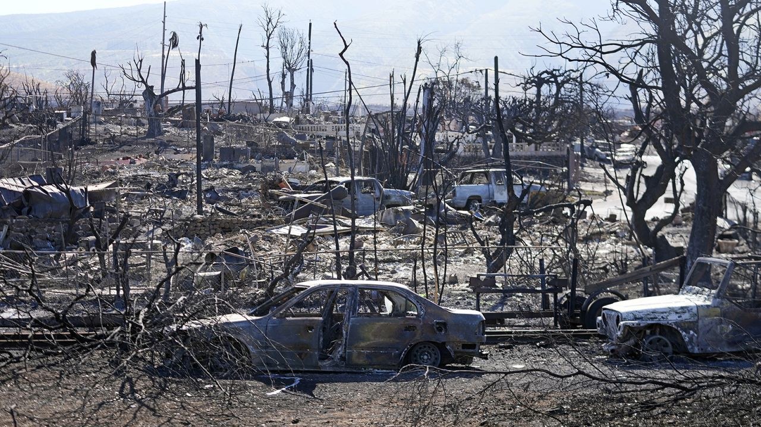

Destroyed homes and cars are shown, Sunday, August 13, 2023, in Lahaina, Hawaii.

Rick Bowmer/AP

The [devastating and deadly wildfires](https://www.cnn.com/2023/08/14/us/maui-wildfires-what-we-know/index.html) in Maui are expected to have an “astronomical” economic on the island and cause a severe local recession, Moody’s Analytics reported Monday.

The economic toll could run between $3 billion and $7.5 billion, according to initial estimates released Monday..

“The price tag is astronomical in the context of Maui’s size, as annual output is about $10 billion,” Adam Kamins and Katie Nied, Moody’s Analytics economists, wrote in the research report.

While those estimates are smaller than the effects of [past major hurricanes](https://www.cnn.com/2022/10/03/economy/hurricane-ian-us-economic-impact-gdp/index.html), they’re higher than typical for wildfires, given the scale of the disaster and that it hit a fairly populated area with more “ferocity” than many [events in California](https://www.cnn.com/2020/10/17/us/california-wildfires-saturday/index.html) and other states, economists wrote.

The lion’s share of the economic impact for Maui is driven by property damage, with about $1 billion being attributed to lost output. Initial estimates suggest that more than 2,000 buildings were either destroyed or damaged, Kamins and Nied noted.

“With the median single-family house price in Maui just above $1 million, the effect on the housing stock alone pulls the estimate into the billions,” they wrote. “Combine this with the loss of a couple of hotels and numerous retail shops, most of which are more highly valued than the typical home on the island, and the number climbs considerably.”

They noted vehicle losses and infrastructure damage accounted for most of the rest of the total. The economic impact could have gone much higher had the fire spread to areas outside of Lahaina, where most of the major resorts are located, they added.

In the medium-term, however, the damage from the fires is expected to drive up house prices in what is already the nation’s [second-least affordable](https://www.cnn.com/2022/08/18/us/hawaii-tourism-impact-united-shades-cec/index.html) metro area, according to the report.

In the near-term, the [heavily relied-upon tourism](https://www.cnn.com/2023/08/10/economy/maui-economy-tourism-wildfires/index.html) income will be severely affected, they noted, adding that the approximately $20 million in daily visitors’ spending will be at risk for at least the next few weeks – if not longer. Job losses will be significant; local and state coffers will take hits from the lost revenue; and a “brief but severe local recession” is anticipated, they added.

The risks extend beyond the island of Maui.

“Many visitors to Hawaii are known to travel to more than one island, which means that the cancellation of entire itineraries will have ripple effects beyond Maui,” they wrote. “Some would-be travelers could also paint all of the Hawaiian Islands with the same broad brush and shy away from visiting, especially after volcanic eruptions on the Big Island in recent years.”

3:13 a.m. GMT+8, August 15, 2023

**60-year-old woman identified by family as one of the victims of the Lahaina fire**

From CNN’s Caroll Alvarado



Carole Hartley

Courtesy Donna Gardner Hartley

Carole Hartley, 60, originally from Grand Bay, Alabama, has been identified as one of the victims of the Lahaina fire, according to her sister Donna Gardner Hartley.

Hartley and her partner, Charles Paxton, were trying to evacuate when the smoke from the fire overwhelmed the couple and they got separated, Gardner Hartley told CNN.

“They were moving fast. The winds were vicious and kept changing. He (Charles) said they were inside a dark smoke (that) felt like a tornado and they could not see nothing, they kept calling each other’s name,” Gardner Hartley said in a Facebook post.  
“He was screaming ‘run, run, run, Carole run.’ He eventually could not hear her anymore,” the post added.

Paxton was eventually found by his friends and organized a search party to look for Hartley after he was treated for his injuries, Hartley’s sister said.

Over the weekend, the search group found Hartley’s remains on the couple’s property, Gardner Hartley told CNN.

Hartley was “smart and resourceful,” Gardner Hartley said.

3:11 a.m. GMT+8, August 15, 2023

**Hawaii's deadly wildfires will be "heavily studied" as the planet heats up, federal scientists say**

From CNN's Rachel Ramirez

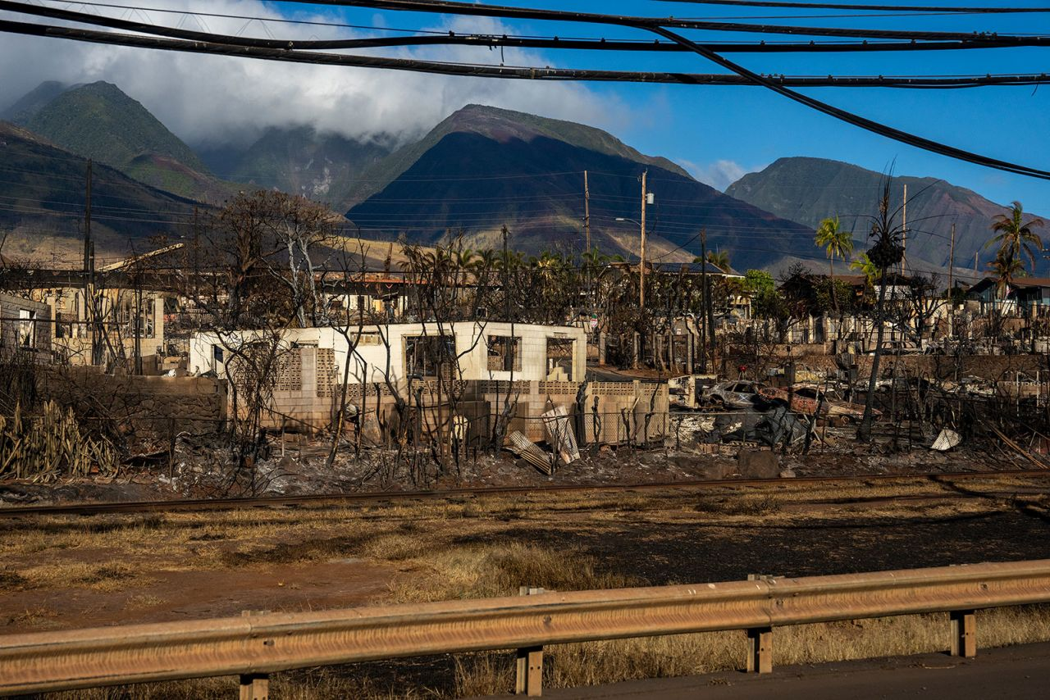

Burned out homes are seen in Lahaina, Hawaii, on August 13.

Evelio Contreras/CNN

The wildfires that tore through the island of Maui and killed 96 people so far, will be “heavily studied” by climate experts as well as US federal research agencies, scientists said.

“There will be lots of research that will come out of NOAA in understanding specifically what caused this and the events that we’ve seen,” Sarah Kapnick, chief scientist with the National Oceanic and Atmospheric Administration, said in a call with reporters Monday.

Gavin Schmidt, director of the NASA Goddard Institute for Space Studies, said there are locally specific precursors and long-term effects that have contributed to the fires, including an ongoing dry spell and the proliferation of nonnative grasses — but climate change may very well have played a role.

“Climate change is a threat-multiplier for wildfires,” Schmidt said. “So there is an overall tendency that we will increasingly see towards greater and more intense wildfires that will be caused by climate change.”

“In this particular example, how much of a contribution [climate change had], that is going to be something that we’re going to be looking at very carefully in the future,” Schmidt added.

The call, which was hosted jointly by NASA and NOAA officials, outlined the latest climate data, in which the planet marked its hottest July in 174 years. The average global temperature in July — the [hottest month on record](https://www.cnn.com/2023/07/27/world/july-hottest-month-record-climate/index.html) by far — was around 1.8 degrees Celsius warmer than the historical average, experts on the call said.

“The bottom line of all this is the last nine years are the warmest on record,” NASA Administrator Bill Nelson said. “And folks, Mother Nature is sending us a message — and that message is we better act now before it’s too late to save our planet.”

4:26 a.m. GMT+8, August 15, 2023

**White House confirms no plans for Biden to visit Hawaii at this time**

From CNN's DJ Judd



White House press secretary Karine Jean-Pierre speaks during the daily news briefing at the White House on Monday in Washington, DC.

Anna Moneymaker/Getty Images

White House press secretary Karine Jean-Pierre confirmed there are no plans in place for President Joe Biden to visit Hawaii after wildfires over the weekend on Maui left at least 96 dead.

“Obviously, I don’t have anything to announce at this time — look, we’re gonna continue to have conversations with the (Federal Emergency Management Agency Administrator Deanne Criswell), certainly the governor in Hawaii, on what the opportunities might be, what that may look like for a trip but right now we just don’t have anything to share,” Jean Pierre said.

Pressed on if Biden will address the wildfires, Jean Pierre said, “Certainly you’ll hear from him, you know, continuously this week,” but she added that she does not have new comments from the president.

“But look, this is something that the president clearly is deeply concerned about, that is why you heard we had the (Criswell) Zoom in right, literally from where she is in Hawaii to talk directly to all of you, to take your questions…and look, you’re going to continue to certainly to hear from us on this issue,” Jean Pierre said.

4:54 a.m. GMT+8, August 15, 2023

**"Nothing can prepare you for what I saw during my time here," FEMA administrator says of Maui wildfires**

From CNN's DJ Judd

The Biden administration is committed to supporting Hawaii “every step of the way” following the deadly Maui wildfires, Federal Emergency Management Agency (FEMA) administrator Deanne Criswell said Monday.

“As residents continue to mourn the loss of their friends, their loved ones, their neighbors, the loss of their homes and their way of life, we know, and let them know that we are mourning with them,” Criswell said during the White House press briefing. “Nothing can prepare you for what I saw during my time here, and nothing can prepare them for the emotional toll of the impact that this severe event has taken on them.”

The FEMA administrator told reporters she’s been “in continuous communication with the president since these fires started,” adding she’s been giving Biden “and his team updates, letting him know what the federal family is doing to support everything that Gov. (Josh) Green has asked for.”

Pressed if President Joe Biden plans to visit Maui to survey damage from the wildfires on the island, Criswell declined to say if there was a visit from the president scheduled.

“Right now, our focus is on making sure that we are doing everything we can to account for everybody that has been unaccounted for — and the President has given me the space to make sure I’m bringing in all of the appropriate federal personnel and resources to do that … We want to make sure that they have, you know, all of the resources and the space that they need and not disrupt operations right now,” she said.

Later on in the briefing, White House press secretary Karine Jean-Pierre confirmed there are no plans in place for Biden to visit Hawaii after the wildfires.

Criswell, who arrived on the ground in Hawaii in the early hours of Saturday morning, highlighted the federal response, noting the FEMA activated its transitional sheltering assistance program while partnering with AirBnB and hotels to “make sure that everyone finds a temporary solution as they begin to develop their plans for rebuilding.”

And she touted “a whole of government approach,” from “dozens of our partner agencies to make sure that we have all of the right resources to support the recovery needs for this area and to make sure that we are successful in providing relief to survivors.”

As part of [those efforts](https://www.cnn.com/2023/08/11/politics/federal-response-to-hawaii-wildfires/index.html), she pointed to work with local partners “to ensure that our outreach and our messaging is also culturally responsive, and that we can get messages out to people so they know what is available to them.”

4:00 a.m. GMT+8, August 15, 2023

**68-year-old Lahaina fire victim found dead with roommate's dog was a kind man, niece tells CNN**

From CNN’s Caroll Alvarado



Franklin “Frankie” Trejos

Courtesy Kika Perez Grant

Franklin “Frankie” Trejos, 68, tried to help others and save his home from burning down before he died trying to escape the Lahaina fire, his niece, Kika Perez Grant, told CNN.

After the fire, Perez Grant said the family received a call from Trejos’ roommate letting them know that the island had been on fire and that he wasn’t sure if Trejos had made it out alive.

“We kept hope alive but then his roommate called us again a few hours later to tell us he had found Uncle Frankie’s remains,” Perez Grant said.

According to Trejo’s niece, her uncle and his roommate tried to save their property at first but then decided to evacuate when they realized it was impossible.

“They both got in their own cars and tried to evacuate. For some reason, his roommate’s car didn’t start, so he crawled around until someone found him. He got badly burned,” Perez Grant said.

Trejos’ roommate then went back to search for Trejo’s car and found the car a few blocks away from the house. Trejos’ remains were found on top of his roommate’s dog who also died, Perez Grant said.

Trejos, who was a native of Costa Rica but had moved to the United States at a young age, has lived in Lahaina for the last thirty years, according to his niece.

“Uncle Frankie was a kind man, a nature lover, an animal lover and he loved his friends and his families with this whole heart,” Perez Grant said. “He loved adventure and was a free spirit.”

1:55 a.m. GMT+8, August 15, 2023

**Hawaii activates more National Guard as US military remains poised to respond to Maui wildfires**

From CNN's Oren Liebermann

More members of the Hawaii National Guard have been activated to respond to the wildfires on Maui, the Pentagon said, and Indo-Pacific Command remains poised to respond should a request for more aid come in.

The Hawaii National Guard has now activated a total of approximately 250 guard members, Brig. Gen. Patrick Ryder said in a briefing Monday.

The National Guard are working with the Hawaii Emergency Management Agency and helping local law enforcement.

CNN [reported](https://www.cnn.com/2023/08/11/politics/federal-response-to-hawaii-wildfires/index.html)last week that two Army National Guard heavy-lift Chinook helicopters are helping with wildlife response operations and the search and recovery teams. To date, crews have dropped more than 189,000 gallons of water to support firefighting efforts.

The US Army Corps of Engineers has also sent debris removal experts and temporary power experts to Maui, Ryder said.

The Army Reserve is also helping the Red Cross by providing additional space at a center in Maui.

Despite a substantial military presence in Hawaii, including the headquarters of Indo-Pacific Command, there has not yet been a request for a larger active-duty response, Ryder said.

“FEMA (Federal Emergency Management Agency) and the Hawaiian Emergency Management Agency, as they put together their response in terms of what’s needed, INDO-PACOM is on a hair trigger to be able to support as necessary, and so we’re going to do that,” Ryder said at the briefing.

Ryder said the Defense Department was coordinating with FEMA and other emergency response agencies to avoid a situation in which military assets flowed in unnecessarily and created logistics problems in a disaster situation.

“Obviously FEMA has a lot of experience in these types of situations,” Ryder said. “We’re going to work closely to make sure we’re getting folks what they need.”

12:41 a.m. GMT+8, August 15, 2023

**Reports: Firefighters describe weak water pressure and failing hydrants during defense of Lahaina**

From CNN’s Gloria Pazmino and Chris Boyette

Several firefighters trying to contain the flames quickly approaching the historic town of Lahaina last week have described weak water pressure and fire hydrants running dry, complicating an already perilous operation.

“There was just no water in the hydrants,” Keahi Ho, one of the firefighters working in Lahaina told the [New York Times](https://www.nytimes.com/2023/08/13/us/lahaina-water-failure.html?smid=nytcore-ios-share&referringSource=articleShare).

Another firefighter, unnamed by the paper because he was not authorized to discuss the operation, said his truck connected to a hydrant but the water pressure was too weak to be of use and the flames grew and spread beyond their ability to contain them.

A third firefighter told the New York Times that when he arrived, he was told there was no water to fight the fires and crews pivoted to prioritize evacuations.

Ho, speaking to CNN, gave a statement, but wouldn’t elaborate on his comments to the paper.

“Any blame on the county or response is misplaced. Lahaina is 150-year-old town and its infrastructure was what it was. The MFD (Maui Fire Department) responded swiftly with heroic effort,” Ho said. “This was an extreme wind and fire event that no department of any size could have stopped. I lost my home and business as did several of my crew.”

Maui County Department of Water Supply Director John Stufflebean told the New York Times that backup generators were in use to maintain the water supply, but as the fire spread, “water was leaking out of the system.” That water was flowing out of their melted pipes as the fire damaged properties.

CNN has reached out to the Maui County [Department of Water Supply](https://www.mauicounty.gov/126/Department-of-Water-Supply) for more information and comment.

1:08 a.m. GMT+8, August 15, 2023

**Hawaii energy company's stock slips after lawsuit blames wildfires on its power lines**

From CNN's Eva Rothenberg

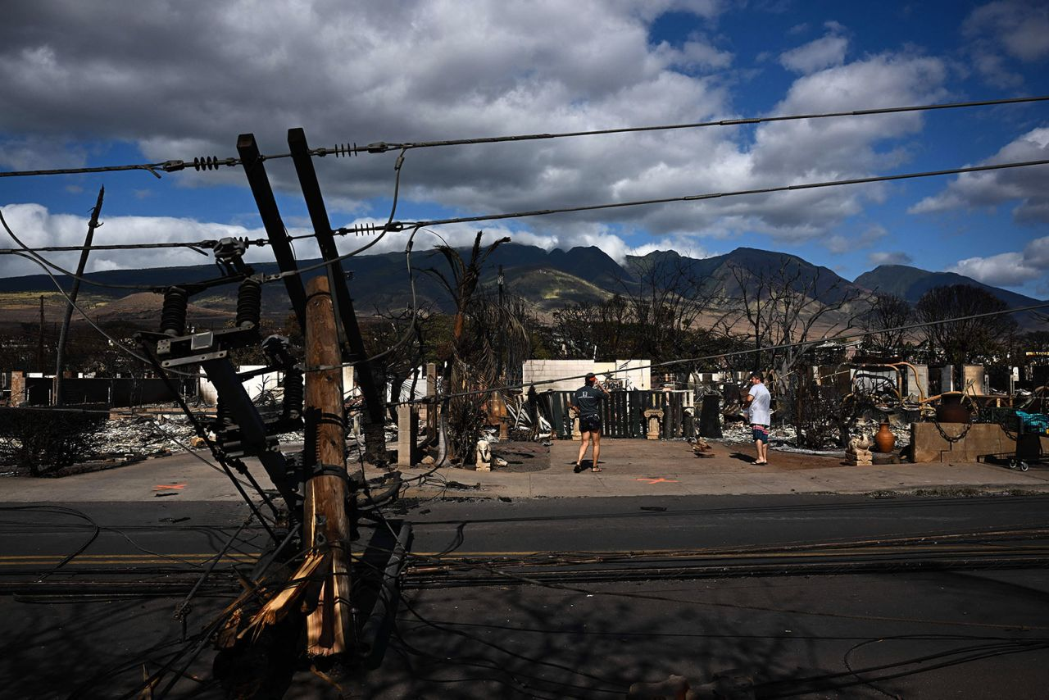

Downed power lines block a road in Lahaina, Hawaii, on August 11.

Patrick T. Fallon/AFP/Getty Images

Hawaiian Electric’s stock tumbled to a 13-year low Monday morning, plummeting nearly 40% after a class-action lawsuit filed over the weekend alleged that Maui’s devastating wildfires were caused by the utility’s energized power lines that were knocked down by strong winds.

The utility says it provides power to 95% of the state’s residents.

The suit alleges that Hawaiian Electric Industries “chose not to deenergize their power lines during the High Wind Watch and Red Flag Warning conditions for Maui before the Lahaina Fire started,” despite knowing the risks of sparking a fire in those conditions.

The company and subsidiaries “also chose not to deenergize their power lines after they knew some poles and lines had fallen and were in contact with the vegetation or the ground,” the suit alleges.

It has not yet been determined what started the wildfire.

**Read more about the**[**Hawaiian Electric’s stocks following the lawsuit**](https://www.cnn.com/2023/08/14/investing/hawaiian-electric-maui-fires-lawsuit/index.html)**.**

6:45 a.m. GMT+8, August 15, 2023

**Cell service returns to Maui in limited capacity**

By CNN's Samantha Murphy Kelly

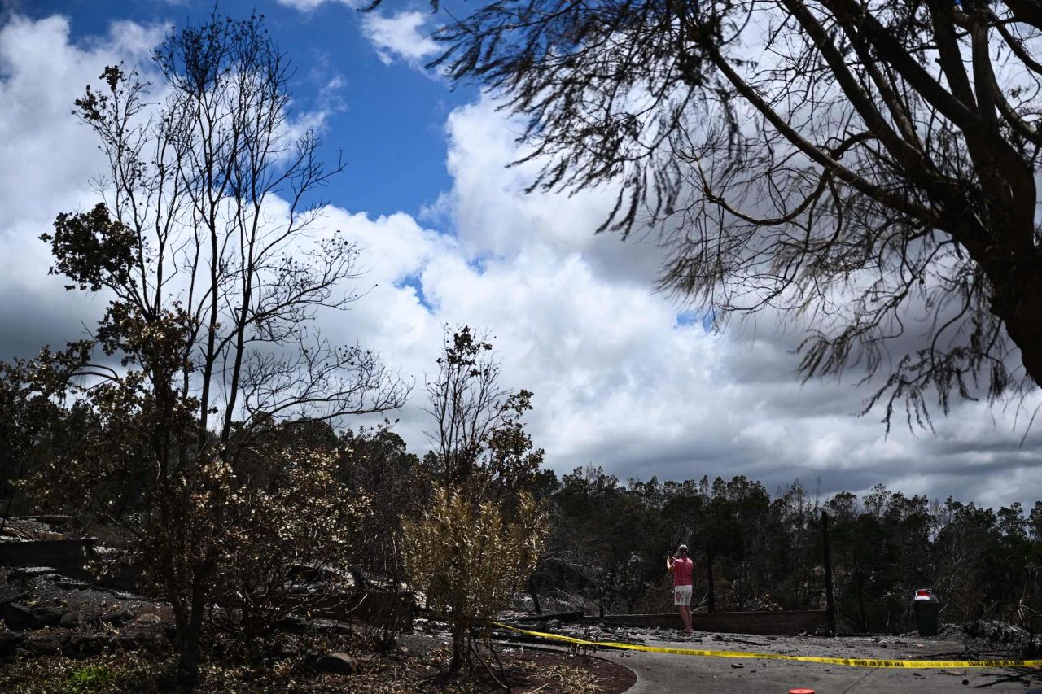

A caretaker photographs the site of a home destroyed by the Maui wildfires in Kula on Sunday.

Patrick T. Fallon/AFP/Getty Images

Mobile carriers continue to work to get cell service back up and running on Maui.

**T-Mobile**: The company told CNN on Monday it has successfully deployed generators to fuel some of its cell towers that lost power due to the fires. T-Mobile is also using small portable cell service terminals to provide connectivity in regions where the network’s fiber connections were destroyed. Additional equipment to provide more cell service is expected to arrive on the island later today.

**AT&T:**The carriersaid it has [restored service](https://about.att.com/pages/disaster-recovery/2023/maui-wildfires) in north Ka’anapali and is using portable satellite solutions and operating drones with cell service support over impacted areas. AT&T said its temporary cell service sites can handle up to 450 calls at a time.

**Verizon**: The company continues to use satellite-based mobile hotspots at evacuation sites [in areas of greatest need](https://www.cnn.com/2023/08/09/tech/cell-service-outages-maui-fires/index.html). Over the weekend, Verizon [said](https://www.verizon.com/about/news/verizon-makes-progress-maui-network-restoration) it restored its cell service towers along Hawaii Route 37 and partial service to a portion of West Maui. Its engineers are working to get a mobile cell site to Lahaina, where there is significant structural damage to its equipment. The company is also working to deploy drones for search, rescue and recovery efforts.

5:03 a.m. GMT+8, August 15, 2023

**Hawaii governor will give an update on the wildfires later today**

From CNN’s Gloria Pazmino

Hawaii Gov. Josh Green is expected to hold a news conference on Maui at 3:30 p.m. local time (which is 9:30 p.m. ET) Monday, his office told CNN.

There have been 96 confirmed deaths from the fire, officials said in an [update](https://www.mauicounty.gov/CivicAlerts.aspx?AID=12694) Sunday night local time. Officials are searching through the wreckage for the many who have been missing since the wildfires broke out.

Around 2,200 structures have been destroyed or damaged in western Maui, where the hard-hit historic town of Lahaina is located, Green previously reported. About 86% of the structures were residential, he added.

9:24 p.m. GMT+8, August 14, 2023

**Here's what it looks like in Maui as communities sift through the ashes of the devastating wildfires**

From CNN's Clint Alwahab

Crews in west Maui are still sifting through the ashes of what used to be homes and beloved landmarks wiped out by the [deadliest US wildfire in more than 100 years](https://www.cnn.com/2023/08/13/us/maui-wildfires-hurricane-dora-sunday?utm_source=trendbar) – and the death toll continues to rise.

There have been 96 confirmed deaths from the fire, officials said in an [update](https://www.mauicounty.gov/CivicAlerts.aspx?AID=12694) Sunday night local time. And there are still people unaccounted for as search teams with [cadaver dogs look for remains](https://www.cnn.com/us/live-news/hawaii-maui-wildfires-08-14-23/h_60c08e9d3028b27e60206d8e52772474) in decimated neighborhoods.

Here’s a look at the aftermath and recovery efforts from the Maui wildfires:

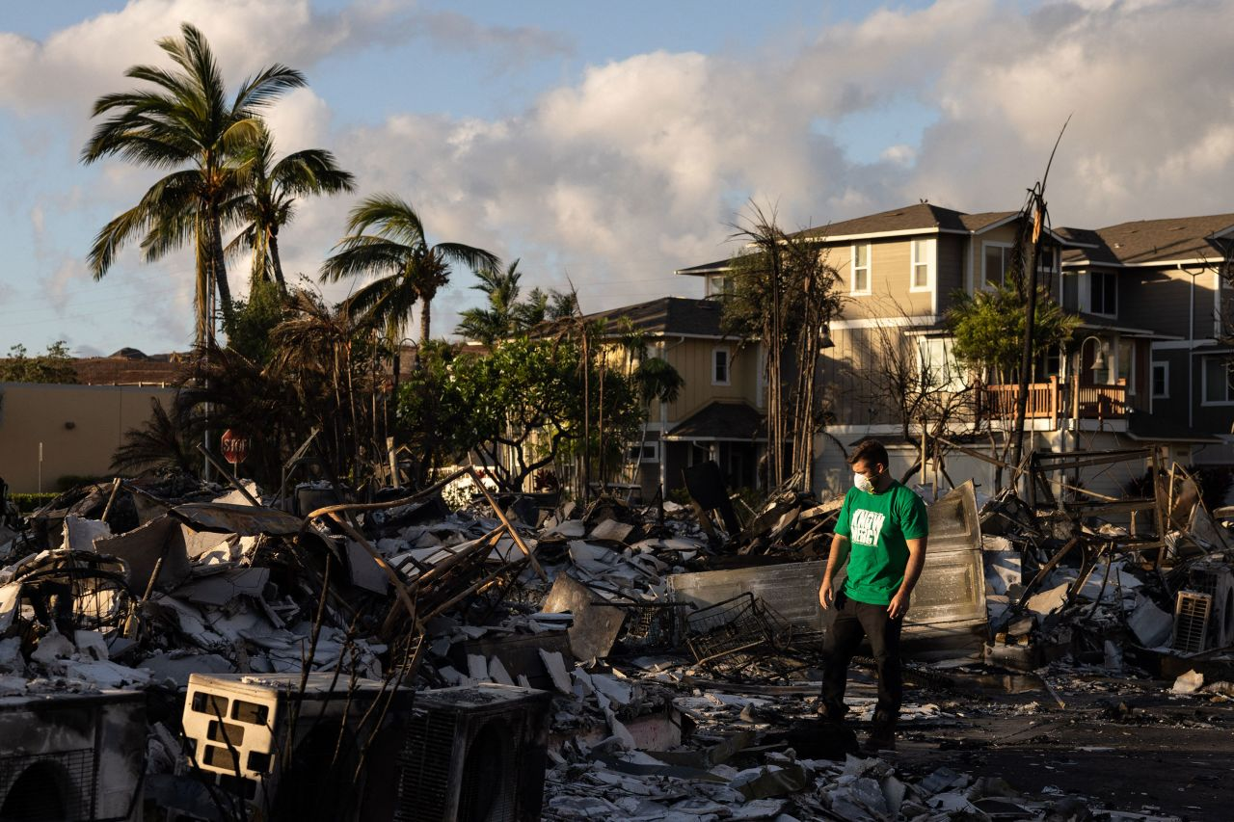

A Mercy Worldwide volunteer makes a damage assessment of an apartment complex in Lahaina, Hawaii, on Saturday.

Yuki Iwamura/AFP via Getty Images

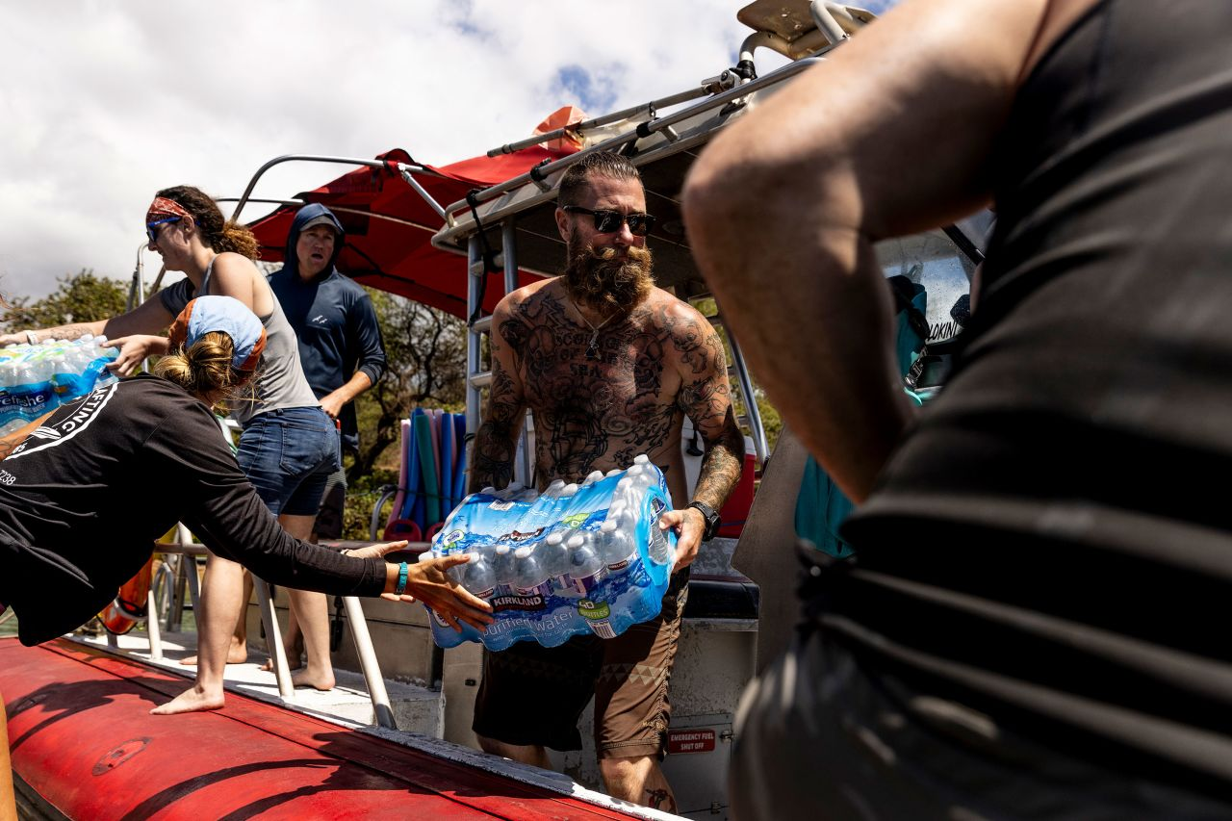

Volunteers load supplies in Kihei onto a boat heading to West Maui on Saturday.

Stephen Lam/San Francisco Chronicle via AP

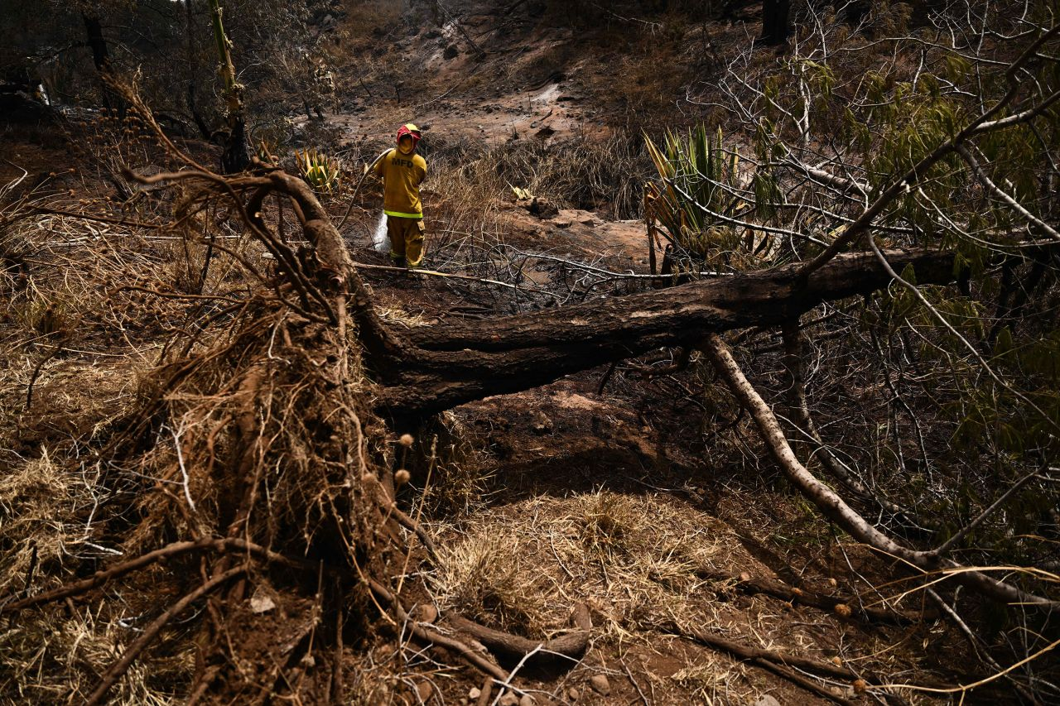

Firefighters work around a fallen tree in Kula on Sunday that was uprooted by high winds.

Patrick T. Fallon/AFP via Getty Images

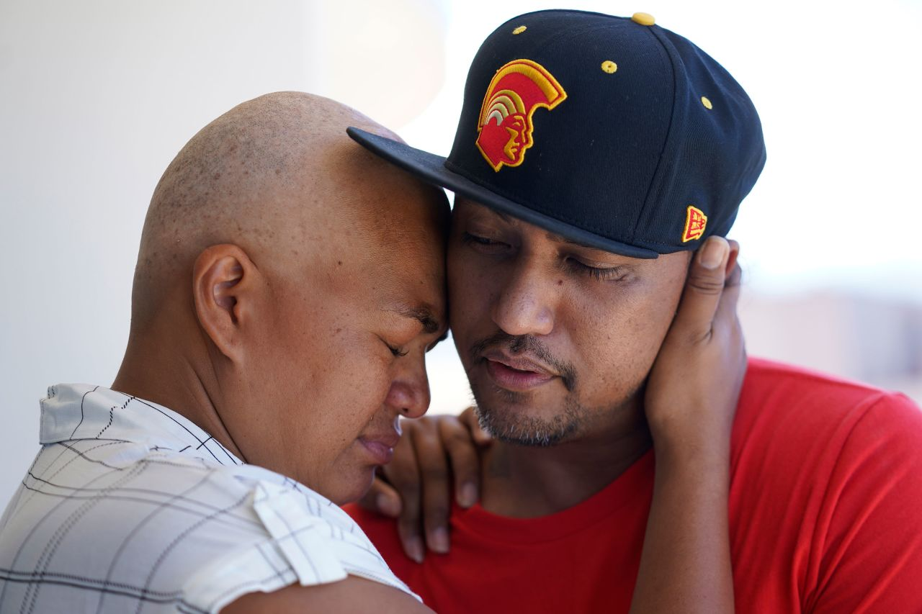

JP Mayoga, right, a chef at the Westin Maui, Kaanapali, and his wife, Makalea Ahhee, hug on their balcony at the hotel and resort near Lahaina on Sunday.

Rick Bowmer/AP

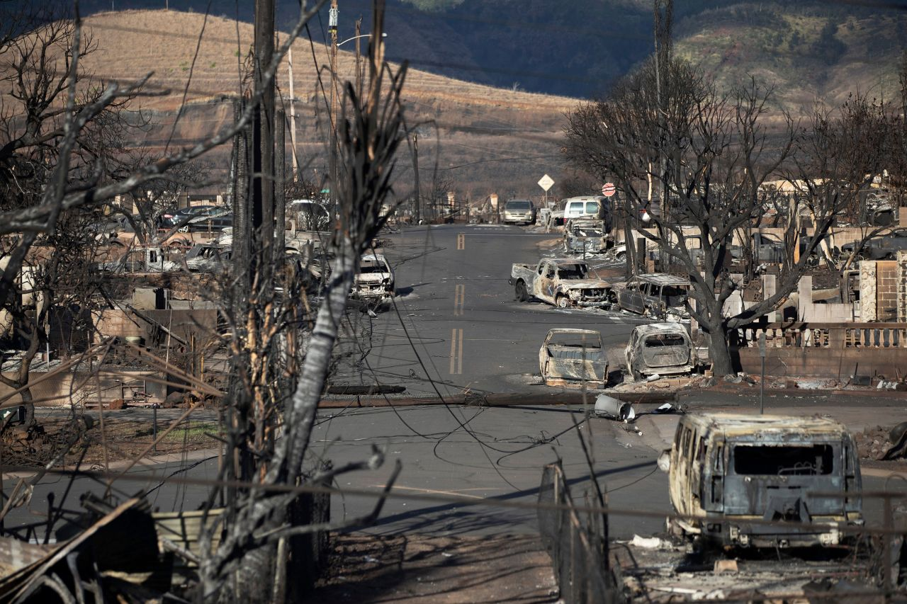

Burnt trees, cars and the ruins of homes are seen in Lahaina on Sunday.

Etienne Laurent/EPA-EFE/Shutterstock

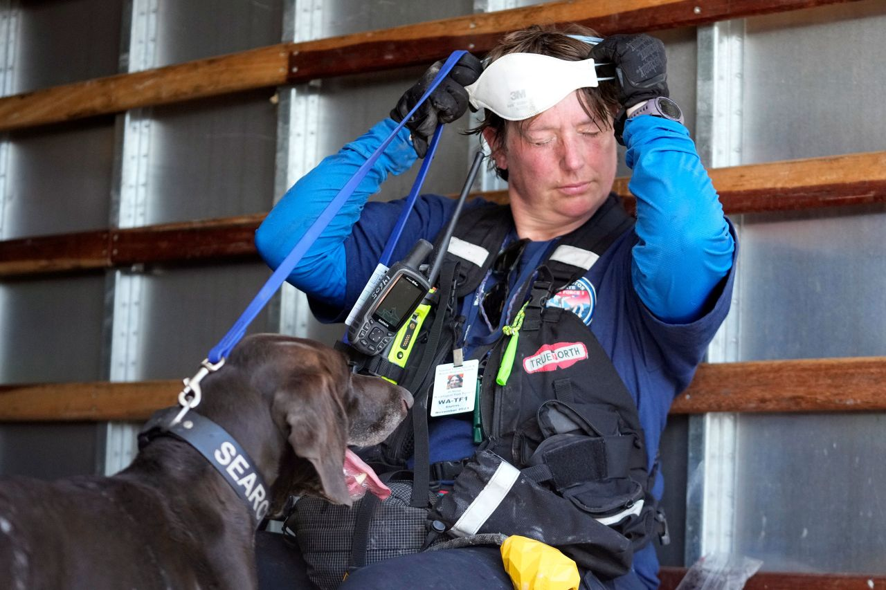

A member of a search-and-rescue team and her cadaver dog cool off near Front Street in Lahaina on Saturday.

Rick Bowmer/AP

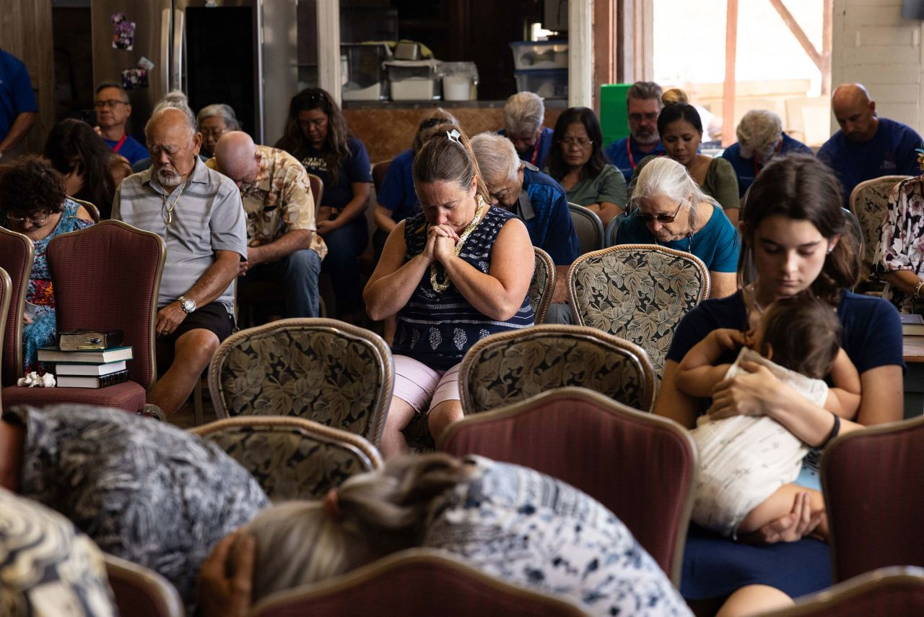

Churchgoers pray during a service held by Pastor Brown of Lahaina's Grace Baptist Church at Maui Coffee Attic in Wailuku on Sunday.

Yuki Iwamura/AFP via Getty Images

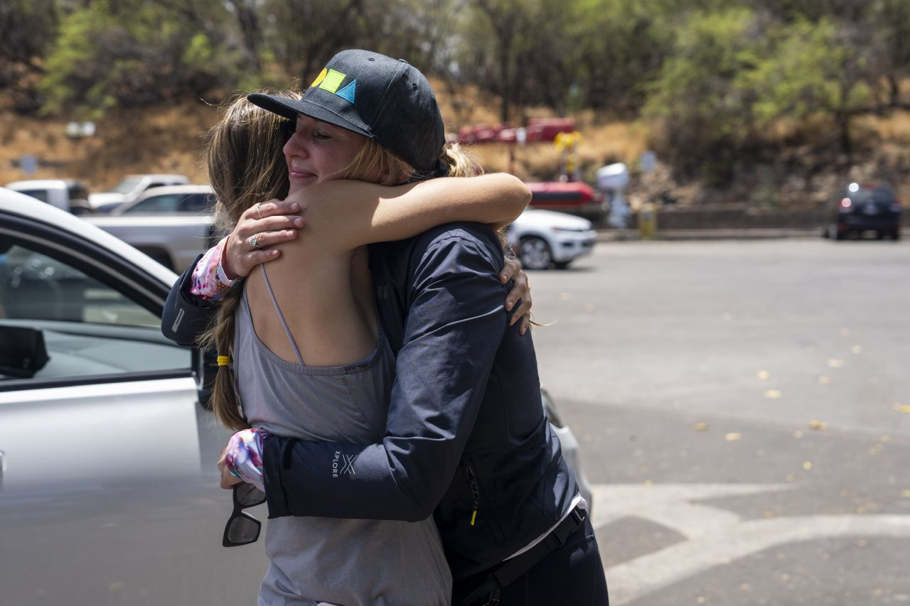

Grace Hurt, right, embraces someone while loading supplies for those in need Saturday at Kihei Ramp on Maui. "The reason why we are out here today is because we have ohana on the west side, boots on the ground that have no roof over their heads," Hurt said. "We are in an effort with the entire community here, we are trying to get them supplies directly."

Evelio Contreras/CNN

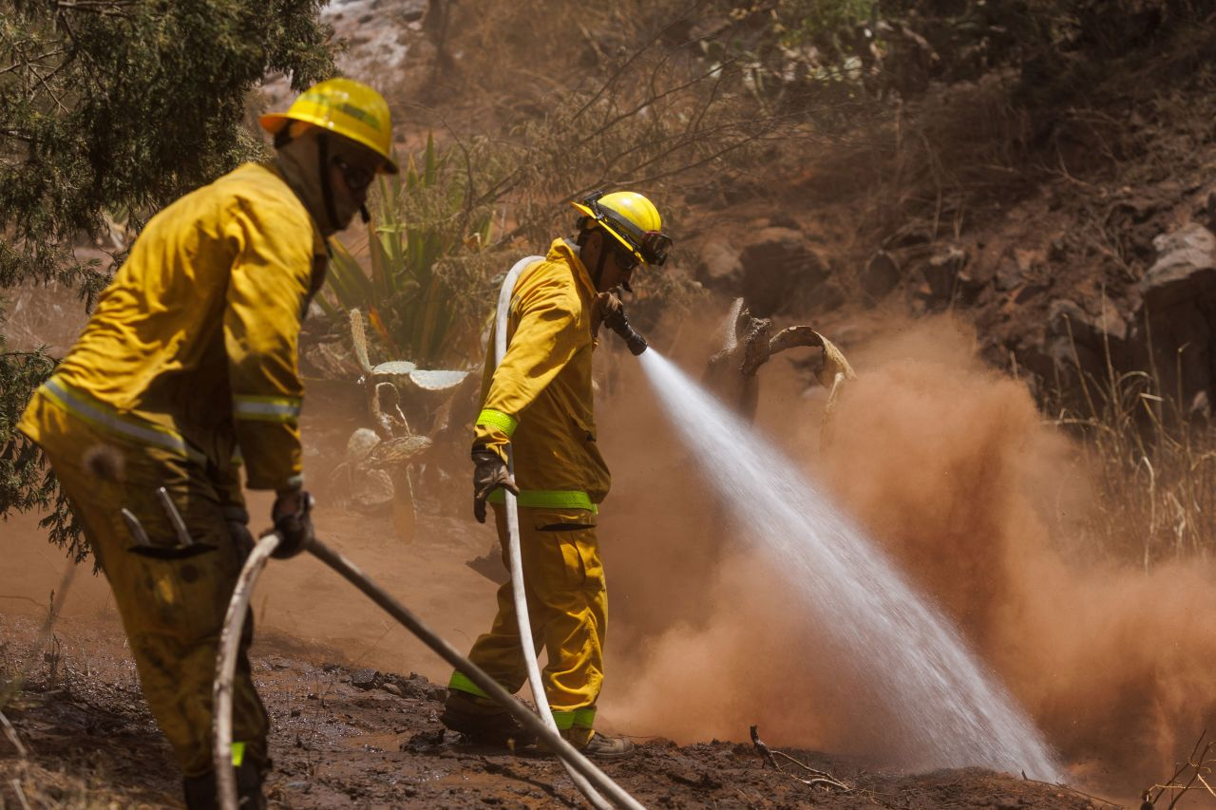

Maui County firefighters douse a flare-up in a canyon in Kula on Sunday.

Mike Blake/Reuters

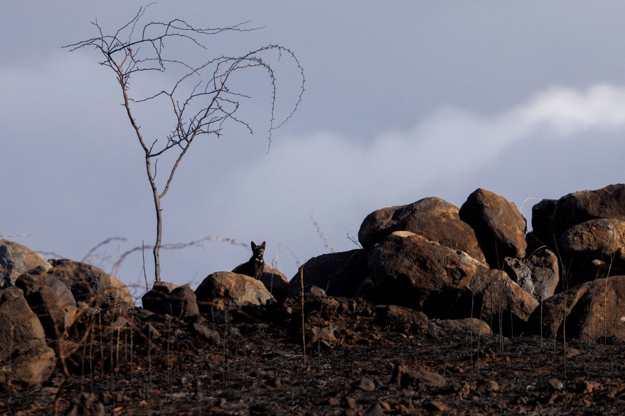

A cat looks out from a burnt field in Lahaina on Friday.

Mike Blake/Reuters

[**See more photos from the catastrophic fires**](https://www.cnn.com/2023/08/10/weather/gallery/maui-fire-gallery/index.html)**.**

7:56 p.m. GMT+8, August 14, 2023

**The death toll in Maui continues to rise. Here's what we know about the wildfire devastation so far**

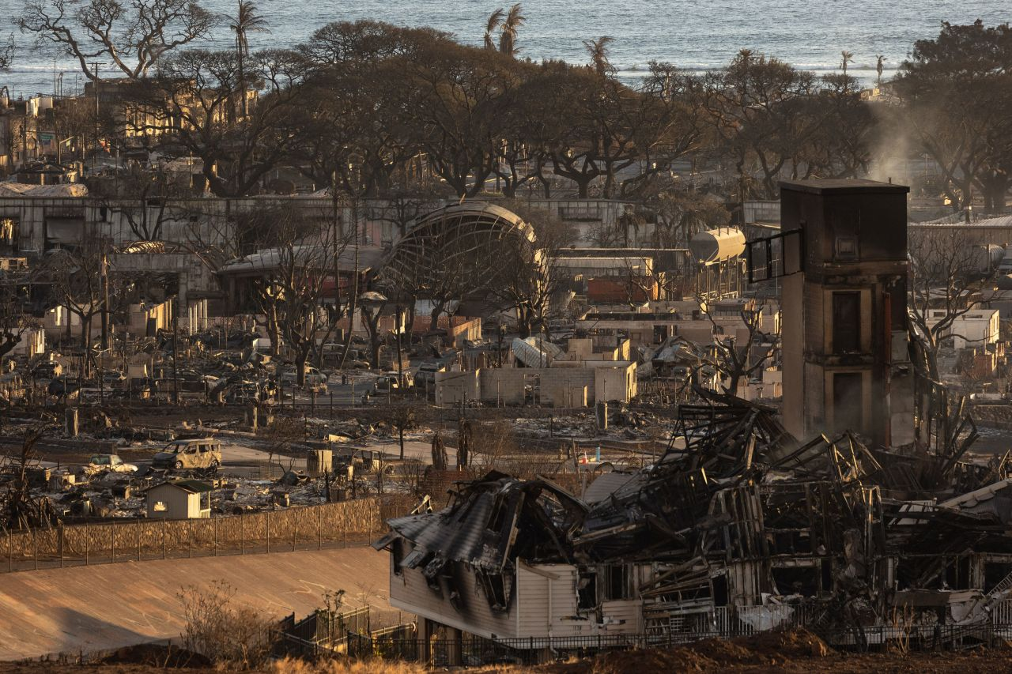

Burned houses and buildings are seen in Lahaina, Hawaii, on Saturday.

Yuki Iwamura/AFP via Getty Images

Crews in west Maui are still sifting through the ashes of what used to be homes and beloved landmarks wiped out by the [deadliest US wildfire in more than 100 years](https://www.cnn.com/2023/08/13/us/maui-wildfires-hurricane-dora-sunday?utm_source=trendbar) – and the death toll continues to rise.

*Here’s what you need to know Monday:*

**Death toll is expected to keep rising:**There have been 96 confirmed deaths from the fire, officials said in an [update](https://www.mauicounty.gov/CivicAlerts.aspx?AID=12694) Sunday night local time. And there are still people unaccounted for as search teams with [cadaver dogs look for remains](https://www.cnn.com/us/live-news/hawaii-maui-wildfires-08-14-23/h_60c08e9d3028b27e60206d8e52772474) in decimated neighborhoods.

**Identifying all the victims won’t be easy:**Dozens of victims were found dead across the burn area, but only two people had been identified as of Saturday, according to [Maui County](https://www.mauicounty.gov/CivicAlerts.aspx?AID=12689). “We have to do rapid DNA to identify everyone,” Maui Police Chief John Pelletier said Saturday, urging those with missing family members to contact authorities to coordinate a DNA test to assist in the identification process.

**The wildfires burned down residences and businesses:**Around 2,200 structures have been destroyed or damaged in western Maui, where the hard-hit historic town of Lahaina is located, according to Gov. Josh Green. About 86% of the structures were residential, he added.

**Struggle to house displaced residents and tourists:**The devastation has displaced thousands of people, FEMA Administrator Deanne Criswell estimated. As of Friday night, a total of 1,418 people were at emergency evacuation shelters, according to Maui County officials. Teams are working to get displaced Lahaina residents into temporary homes, with more than 500 hotel rooms already obtained with government subsidies, Green said Sunday.

**Warning sirens were not activated:**As the deadly fires spread rapidly into neighborhoods, [the largest siren system in the world was silent](https://www.cnn.com/2023/08/12/us/hawaii-emergency-warning-system-maui-wildfires/index.html). Emergency communications with residents were largely limited to mobile phones and broadcasters at a time when most power and cell service was already cut. “There were multiple fires at the same time, and the circumstance was greatly complicated also by the heat and the speed with which the fire spread, destroying a great deal of infrastructure,” Green said Saturday when asked about why sirens weren’t heard.

**Hawaii’s main electric provider sued:** [A lawsuit claims](https://www.cnn.com/us/live-news/hawaii-maui-wildfires-08-14-23/h_5c075b44fe2880da1f6a44e3b1b992b3) electrified power lines blown over by high winds helped to cause the destructive Lahaina wildfire. The complaint was filed Saturday against Hawaiian Electric Industries and three subsidiaries, including the power utility that services Maui. Mayor Bissen acknowledged Thursday that power lines that were “still energized” had fallen on the roads, but the new lawsuit does not state exactly how the power lines allegedly caused the wildfire. An official cause of the wildfire has not yet been determined.

7:16 p.m. GMT+8, August 14, 2023

**10 cadaver dogs are working in Maui to identify human remains that might be burnt beyond recognition**

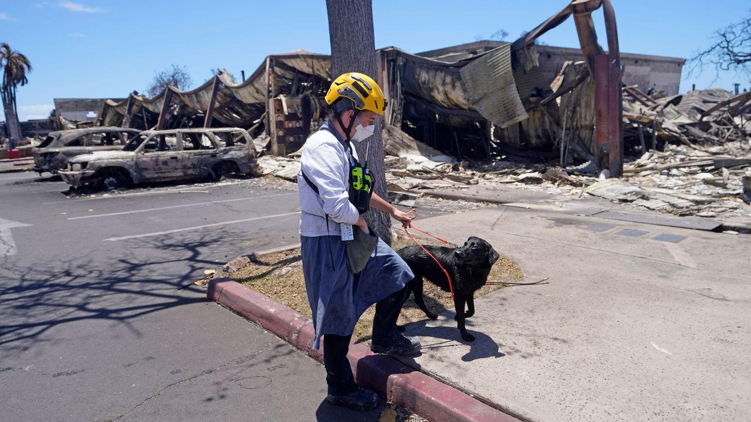

A member of a search and rescue team walks with her cadaver dog near Front Street in Lahaina, Hawaii, on Saturday.

Rick Bowmer/AP

Twisted metal. The carcases of burned sedans. Charred shells of what once were homes, thriving businesses and cultural landmarks. As Maui officials continue [searching through the wreckage](https://www.cnn.com/2023/08/13/us/maui-wildfires-hurricane-dora-sunday/index.html) for the many who are still missing after wildfires tore through the island, they have a new tool at hand: human remains detection dogs, often called cadaver dogs.

The wildfires, whipped by strong winds from Hurricane Dora offshore, ravaged the once vibrant Hawaiian island, killing at least 96 people. Only two of the dead have been identified as of Saturday.

The disaster is[the deadliest US wildfire in over 100 years](https://www.cnn.com/us/live-news/hawaii-maui-wildfires-08-13-23/index.html), according to research from the National Fire Protection Association. Officials have acknowledged the death toll is likely to increase and the true scale of the casualties is unclear. And spotty cell phone coverage has added to the confusion over missing friends and family.

Cell signals are improving – some families have finally been able to reach their loved ones through text – and Maui County has said that a community center is open to provide resources for people looking for information about missing people.

There were a total of 10 search dogs from the Federal Emergency Management Agency’s Urban Search and Rescue teams in Maui as of Friday, a representative from the agency told CNN, and more are set to join the search effort.

The dogs and their handlers have taken on the harrowing job of searching through the ruins to identify human remains that might be burnt beyond recognition, so authorities can begin the process of matching them with names and notifying families.

Just 3% of the fire zone had been searched with cadaver dogs as of Saturday night, according to Maui Police Chief John Pelletier. “None of us really know the size of” the death toll yet, he told reporters. He urged those with missing family members to contact authorities to coordinate a DNA test to assist in the identification process.

**Read more about**[**the cadaver dogs working in Maui**](https://www.cnn.com/2023/08/14/us/cadaver-dogs-maui-wildfires-victims/index.html)**.**

6:33 p.m. GMT+8, August 14, 2023

**Many Maui schools will reopen today, with students returning Wednesday**

From CNN’s Amanda Jackson

Staff at most of Maui’s public schools will return to campus Monday, except for West Maui and King Kekaulike High, as the state’s Department of Education beings phased school reopenings since wildfires devastated the island.

“From the bottom of my heart, thank you for the strength, leadership and courage you’ve shown throughout this tragedy that has shaken Lāhainā, our Maui communities and all of Hawai‘I,” reads [a letter Superintendent Keith Hayashi](https://www.hawaiipublicschools.org/ConnectWithUs/MediaRoom/PressReleases/Pages/Superintendent-Lahaina-Message.aspx)wrote to staff and students on Sunday. “The loss you are experiencing is unimaginable — the loss of loved ones, of homes and neighborhoods, of a school and a community.”

Staff at the public schools in Upcountry, South and Central Maui will report to campus on Monday with students returning on Wednesday. Campuses will be closed on Friday due to a state holiday.

Previously, Maui High School was a [site of the Red Cross evacuation shelter](https://www.mauicounty.gov/CivicAlerts.aspx?AID=12689) but on Sunday the shelter was relocated to the South Maui Gymnasium in Kihei.

With West Maui schools closed, the department and Hayashi encourage displaced families to reenroll their students in the nearest school, even if it is on a temporary basis.

Hayashi reassured employees impacted by the school closures that their jobs are safe and they will continue to be paid while on administrative leave.

“Please prioritize taking care of yourself and your loved ones during this time,” Hayashi said.

Hayashi ends the letter by thanking the community and staff:

 “Our hearts are heavy, and the road to recovery will be long, but I have faith in our collective strength to support one another and our students. Together, we will heal, we will rebuild, and Lāhainā and Maui will thrive once more.”

3:05 a.m. GMT+8, August 15, 2023

**Nearly 100 people have died in the Maui wildfires, officials say**

From CNN's Michelle Watson

The death toll from the Maui, Hawaii wildfires is now at 96 as of Sunday night local time [according](https://www.mauicounty.gov/CivicAlerts.aspx?AID=12694) to a news release from Maui County.

**“Maui Police Department around 9 p.m. said there are 96 confirmed fatalities,” the release said.**

The Kula fire, first reported August 8, is now 60% contained, the county reported, and the Lahaina fire, also first reported August 8, is 85% contained.

The Pulehu/Kihei fire remains 100% contained and the Puʻukoliʻi/Kaanapali fire is extinguished.

5:13 p.m. GMT+8, August 14, 2023

**Lawsuit against power company alleges blown-over power lines led to wildfire spread**

From CNN’s Andy Rose

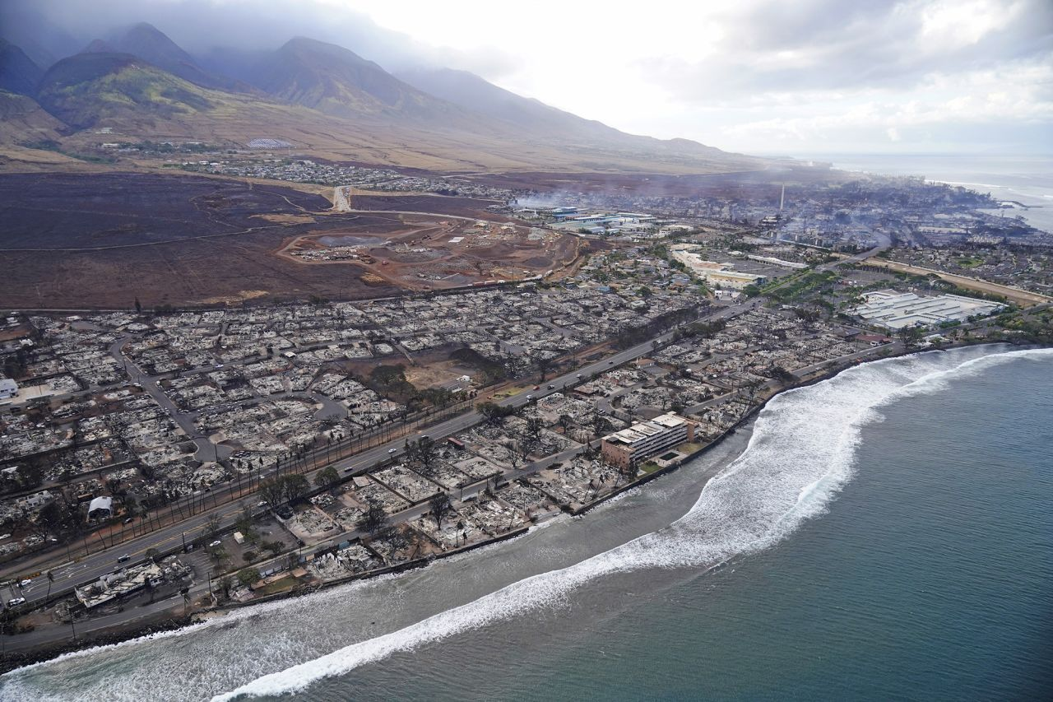

The aftermath of the wildfire in Lahaina, Hawaii, on August 10.

Rick Bowmer/AP

A lawsuit filed against Hawaii’s main electric provider alleges that electrified power lines blown over by high winds during Hurricane Dora led to the spread of the deadly Lahaina wildfire.

The complaint was filed Saturday by three law firms on behalf of a couple living in Lahaina against Hawaiian Electric Industries and three subsidiaries, including the power utility that services Maui.

Attorneys are asking a judge to certify the case as a class action suit covering everyone who lost property or was physically hurt in the Lahaina fire.

“These power lines foreseeably ignited the fast-moving, deadly, and destructive Lahaina Fire, which destroyed homes, businesses, churches, schools, and historic cultural sites,” the lawsuit alleges.

**Wildfire cause remains unknown:**Maui Mayor Richard Bissen acknowledged Thursday that power lines that were “still energized” had fallen on the roads, but the new lawsuit does not state exactly how the power lines allegedly ignited the wildfire. An official cause of the wildfire has not yet been determined.

The fires on Maui started spreading widely Tuesday — fueled in part by violent winds from Hurricane Dora, churning more than 800 miles away — decimating homes and businesses, launching urgent rescue missions, knocking out power and communication services, and even forcing some people into the ocean to avoid being burned.

**The allegations:**The suit alleges that Hawaiian Electric Industries “chose not to deenergize their power lines during the High Wind Watch and Red Flag Warning conditions for Maui before the Lahaina Fire started,” despite knowing the risks.

The company and subsidiaries “also chose not to deenergize their power lines after they knew some poles and lines had fallen and were in contact with the vegetation or the ground,” the suit alleges.

**Utility’s response:**Hawaiian Electric vice president Jim Kelly told CNN Sunday via email that, “as has always been our policy, we don’t comment on pending litigation.”

“Our immediate focus is on supporting emergency response efforts on Maui and restoring power for our customers and communities as quickly as possible. At this early stage, the cause of the fire has not been determined and we will work with the state and county as they conduct their review,” Kelly said.

Government officials in Hawaii repeatedly declined to say last week what could have been done to prevent the wildfire spread, saying that will be determined by a “[comprehensive review](https://ag.hawaii.gov/wp-content/uploads/2023/08/News-Release-2023-36.pdf)” ordered by Hawaii Gov. Josh Green.

*This post has been updated with additional information.*

4:56 p.m. GMT+8, August 14, 2023

**Hawaii senator says she won't "make any excuses" as state reviews its wildfire response**

From CNN’s Raja Razek

As [the deadliest US wildfire in more than 100 years](https://www.cnn.com/2023/08/13/us/maui-wildfires-hurricane-dora-sunday/index.html) broke out and Maui lost power and communications, the largest siren system in the world remained silent. Some residents say they did not receive an official warning, and there have been complaints that officials were [woefully unprepared](https://www.cnn.com/2023/08/11/us/hawaii-wildfire-threat-invs/index.html) for wildfires.

**“I am not going to make any excuses for this tragedy,” US Sen. Mazie Hirono of Hawaii told CNN’s Jake Tapper Sunday. “But the attorney general has launched a review of what happened with those sirens and some of the other actions that were taken.”**

The senator added that there will be a time coming up for those kinds of reviews and investigations, but she is now focused on the need for rescue.

Hirono spoke with Tapper Sunday morning, a day after surveying the damage on Maui with the state’s governor and the director of the Federal Emergency Management Agency.

“The entire historic town of Lahaina burned to the ground,” she said, adding that there were images of cars that were totally demolished. “We saw a group of cars near the ocean, and it is quite clear that the occupants of those cars probably fled into the ocean, and I was told at least 12 people were rescued from the ocean in that location.”

The senator also discussed the people who are still missing, saying “we are in a period of mourning and loss.”

“Some of them have been accounted for, some of them have been found in the shelters,” she said. “I visited one with some 400 residents sleeping on cots, and we are going to need to provide them with short-term and long-term housing.”

Hirono also spoke about resources and government agency support while acknowledging the state is in a period of “shock and loss.”

“We know that recovery will be long, and the resources will be necessary,” she said. “The focus right now is truly on recovery. There are still people who are unaccounted for. They need to be identified. There is a call for people to come in to provide DNA.”

On climate change, and if the senator would like President Joe Biden to declare a climate emergency, Hirono said “we very much need to acknowledge that climate change is upon us,” adding that “more needs to be done.”

“There is not enough recognition that we are going to need to combat these kinds of wildfires,” she said. “We need to be to be assessing our ability to contend with these kinds of natural disasters, which we are seeing more of the frequency and the damage that is done. Clearly, this is happening all across the world,” the senator added.

5:18 p.m. GMT+8, August 14, 2023

**Maui faces struggle between housing for displaced residents and tourism**

From CNN’s Andy Rose

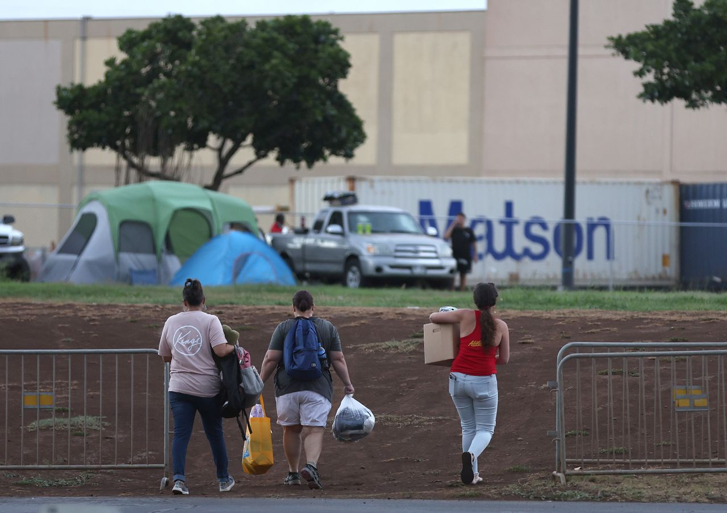

Volunteers with King's Cathedral Maui bring supplies to a displaced family that is camping on church property on August 10, in Kahului, Hawaii.

Justin Sullivan/Getty Images

As the Hawaiian island of Maui receives help from around the world in recovering from its [deadly wildfires](https://www.cnn.com/2023/08/13/us/maui-wildfires-hurricane-dora-sunday/index.html), some residents say the greatest need is something that can’t be shipped in from the mainland: a place to stay.

“We’re short on housing here,” Mike Cicchino told CNN’s Jessica Dean on Sunday. His family is now staying in Kihei after the fire encroaching on his Lahaina home forced him to [take refuge along the seawall for 12 hours](https://edition.cnn.com/us/live-news/hawaii-maui-wildfires-08-12-23/h_b0e99a9bda555302370811be36abaf2e). “We just went through a nightmare, and we’re about to go through another nightmare trying to, basically, not stay homeless.”

Hawaii officials have stressed in news briefings that the island is not closed to tourists, particularly the eastern side that was unaffected by wildfires. While one runway of Kahului Airport has been closed to general aviation in order to allow more cargo shipments in, the Department of Transportation said commercial flights onto Maui are unaffected. The Covid-19 pandemic forced the island to effectively shut down its largest economic engine for months, and officials are anxious not to discourage visitors again.

Cicchino said that is effectively forcing evacuated residents of West Maui to compete with tourists for housing.

“I hate to say it, but I think they should put a little hold on people coming to visit because we don’t have any places for locals to stay,” he said. “They’re going to need those hotel rooms. They’re going to need our Airbnbs, Vrbos.”

While there are mass shelters available for evacuees, Cicchino says he’s not sure how long that can be a viable solution.

**“We’re in desperate need out here,” he said. “A lot of people have nowhere to go.”**

4:56 p.m. GMT+8, August 14, 2023

**Here's how to know your wildfire relief donation is going to a legitimate charity**

From CNN's Samantha Delouya

If you’re looking to donate money to help those affected by the wildfires in Hawaii, it’s important to follow certain steps to ensure your money is going to the right place.

*Here are tips to make sure your donation is going to a legitimate charity:*

**How to pick the organization:**Several sites help people find and support legitimate charities, including [Charity Navigator](https://www.charitynavigator.org/), [BBB Wise Giving Alliance](https://give.org/) and [CharityWatch](https://www.charitywatch.org/). Dig deeper into an organization’s reputation after finding a legitimate charity you’re considering supporting.

The US [Federal Trade Commission](https://consumer.ftc.gov/articles/giving-charity) suggests when conducting an online search of any charity, you should add the words “complaint,” “review,” “fraud,” or “scam” to the search terms.Doing this should bring up any bad reviews or red flags about the organization.

It’s also helpful to know if the group you’ve selected is registered as a 501(c)3, meaning it’s registered as a tax-exempt non-profit. Look up the organization in the IRS’s [Tax Exempt Organization Search](https://www.irs.gov/charities-non-profits/tax-exempt-organization-search). If the charity is a registered 501(c)3, you may want to save a record of your contribution since it’s tax deductible.

When you feel confident about making your donation, it’s best to use a credit card or check, since those types of payments are easily traceable. After contributing to a charity, review your bank account and credit card statements to ensure you’ve only been charged the agreed-upon amount.

**Tips for donating through a platform like GoFundMe:**When donating through a platform like GoFundMe, ActBlue or WinRed, make sure to check whether the site is keeping some of your donation as a processing fee.

For many crowdfunding sites, your money will first go directly to the crowdfunding organizer, and not necessarily the end-recipient of the donations. So double-check that the organizer will pass along the funds to the person or cause they claim to be supporting.

**Be on the lookout for scams:** Don’t let anyone rush you into donating on the phone on the spot; take time to do the proper research. Never donate with a wire transfer or gift card, which is difficult to track if something goes awry. Also, if an organization insists on a donation using cryptocurrency, another hard-to-track form of payment, that should set off alarm bells. Avoid sending funds from payment apps like Venmo or Zelle. Those apps should only be used to send money to people you know, since it’s difficult to recoup funds once someone receives them.